**Flow Diagram:**

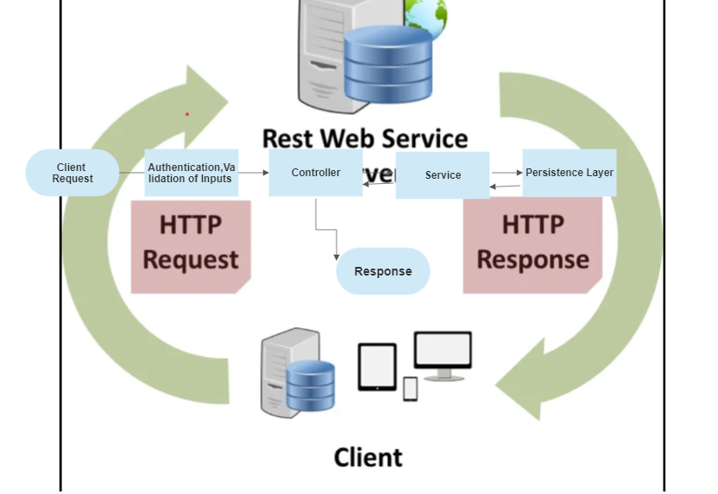

**Design considerations:**  Below key principles I have followed to design and develop Rest full API

1. Followed Layered ,Loose coupled design approach – Clear Separation for responsibility.
2. Designing meaningful end points with usage of proper HTTP methods .
3. Considered Idempotency in Resource create/modification in API’s
4. Data base modelling– followed normalisation principle – Used in memory db (h2)

for time being can be replaced with any SQL database. Ideal solution would be NoSql for

better performance

1. Keeping in mind Security – Implemented input validation and proposing authentication and authorization with JW.
2. Centralizing the cross cutting concerns - Logging , Performance metrics
3. Performance Optimisation - Index
4. Request processing– Proper error handling ,quick filtering – Pagination ,Sorting and Addition information about resource.
5. Performance ,Reusability, Scalable ,Readability
6. Improve the application performance with cache layer - Proposed
7. API Documentation with Swagger
8. Unit test cases with Junit & Mockito
9. Integration test cases with Wiremock.

**API’s Implemented**

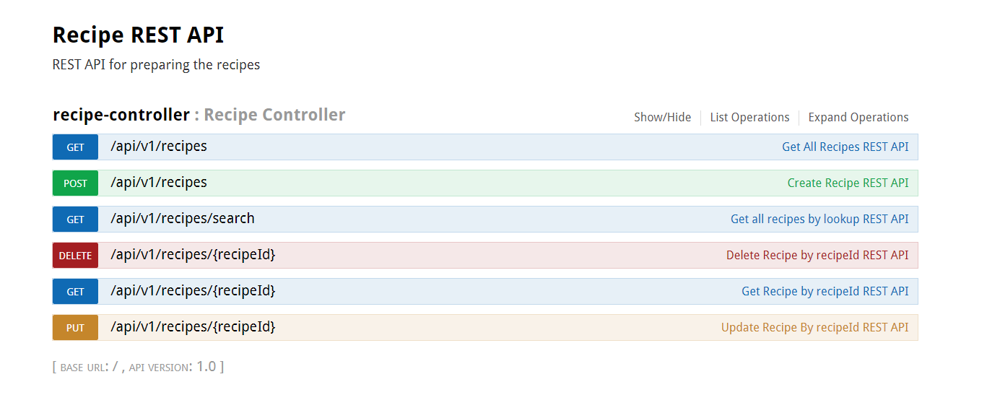

Junit Test case Report

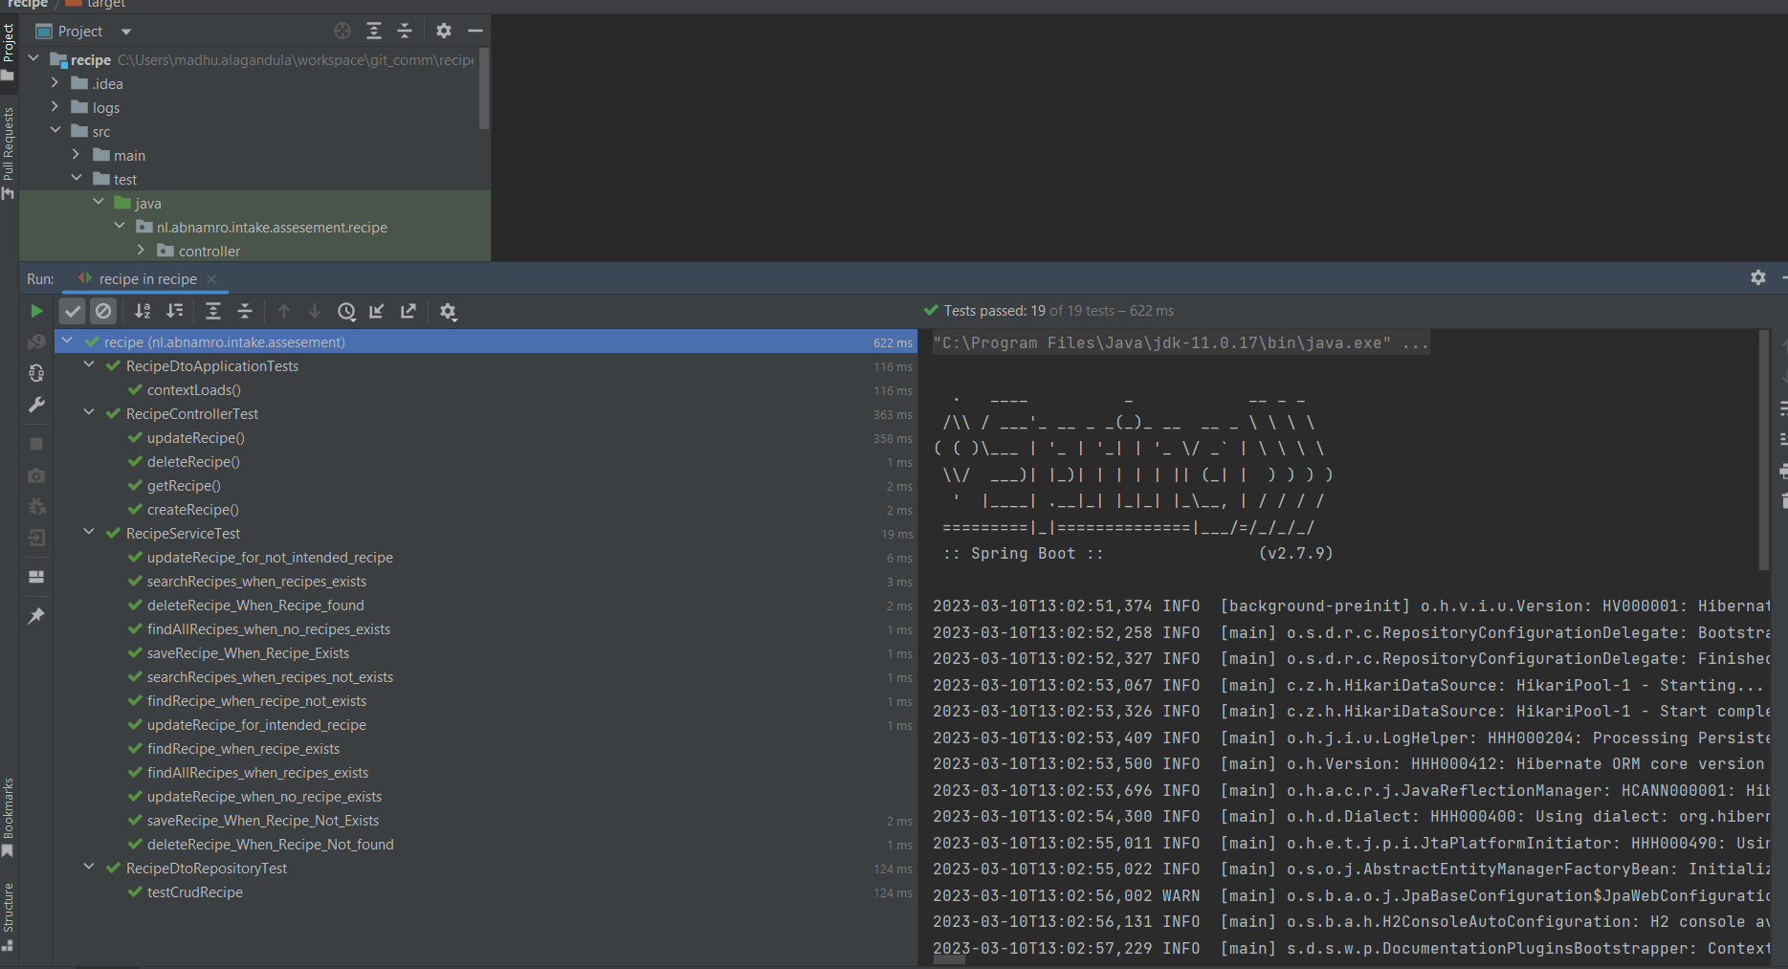

Code Coverage Report:

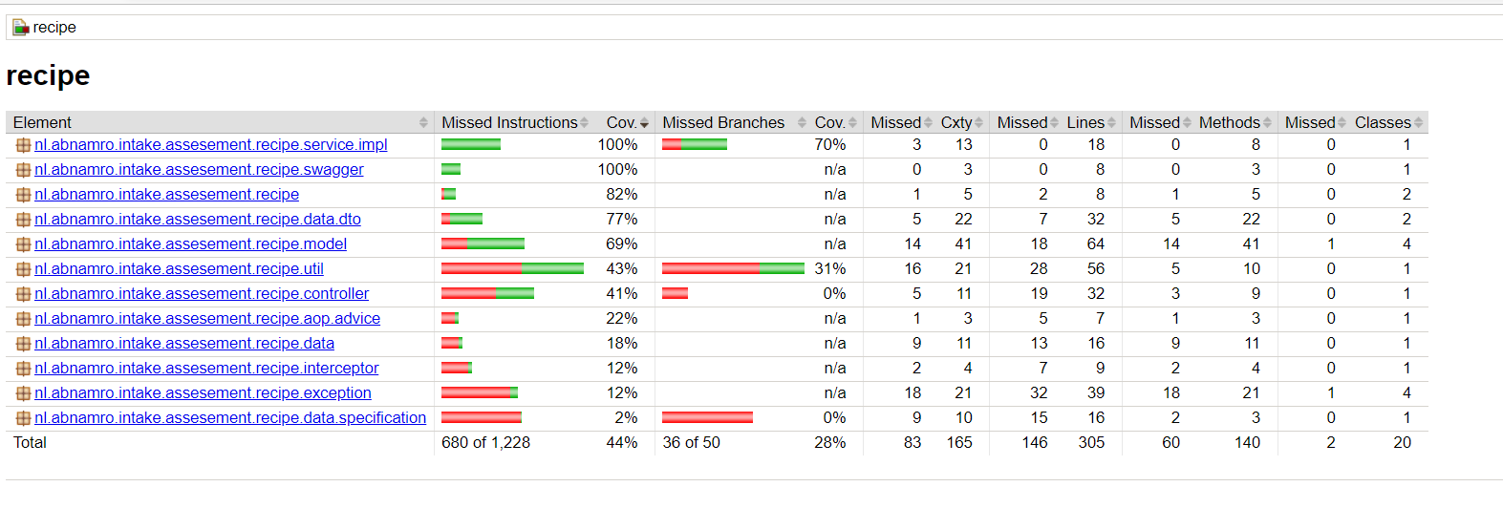

Integration Test cases with wiremock:

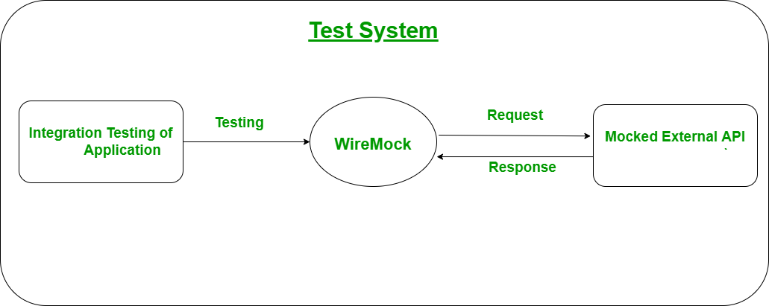

**Working with API:**

1. **Create Recipe:**

Endpoint: <http://localhost:8080/api/v1/recipes>

Http Mehod: POST

Request Body: {

    "name":"Chicken Biryani",

    "serves":"1",

    "dishType": "Non Veg",

    "instruction": "instruction",

    "decription":"Delicious Dum Biryani",

    "ingredients" : [{

        "name":"Chicken 500 grams",

        "name":"Red Chilli powder 5 spoons",

        "name": "salt 2 spoons"

    }]

}

Response Body:

{

    "status": 201,

    "data": [

        {

            "name": "Chicken Biryani",

            "recipeId": 1,

            "dishType": "Non Veg",

            "instruction": "instruction",

            "ingredients": [

                {

                    "ingredientId": 1,

                    "name": "salt 2 spoons"

                }

            ]

        }

    ],

    "timestamp": "2023-03-08T10:06:36.007+00:00"

}

Example

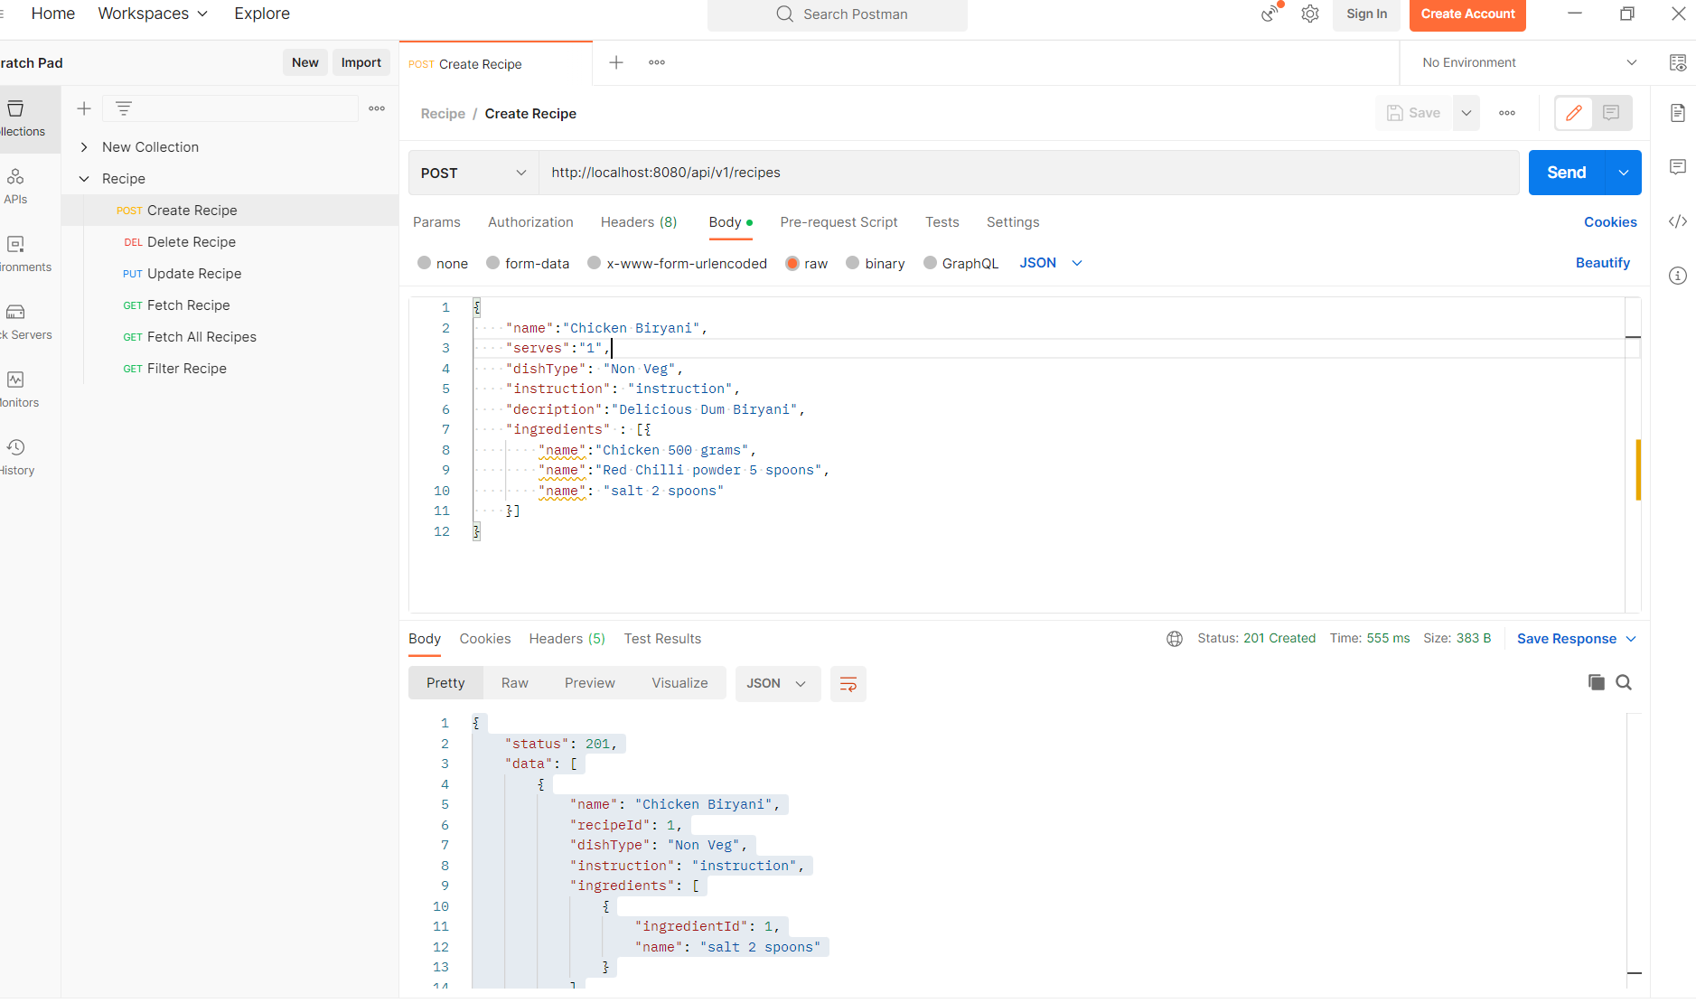

1. **Find Recipe By recipeId:**

Endpoint: [http://localhost:8080/api/v1/recipes/{recipeId}](http://localhost:8080/api/v1/recipes/1)

Http Method: GET

Request Body: No

Response Body:

{

    "status": 200,

    "data": [

        {

            "name": "Chicken Biryani",

            "recipeId": 1,

            "dishType": "Non Veg",

            "instruction": "instruction",

            "ingredients": [

                {

                    "ingredientId": 1,

                    "name": "salt 2 spoons"

                }

            ]

        }

    ],

    "timestamp": "2023-03-08T10:08:40.351+00:00"

}

Example

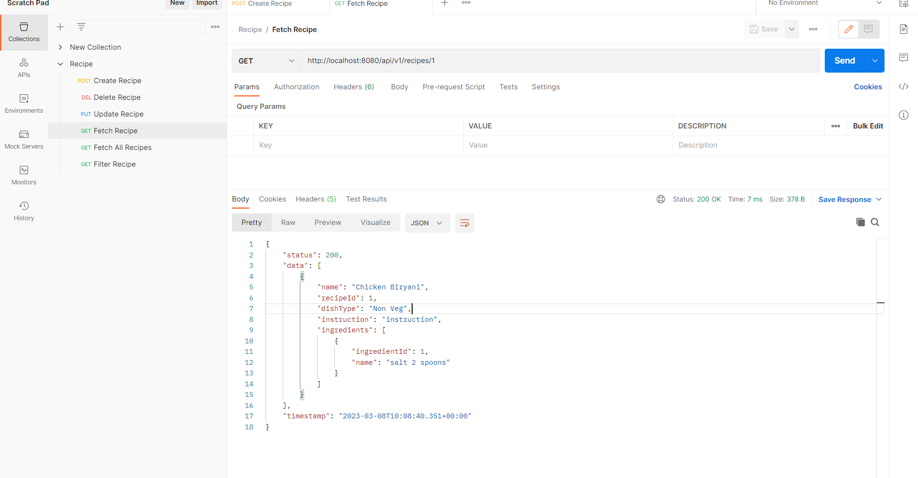

1. **Delete Recipe by recipeId:**

Endpoint: [http://localhost:8080/api/v1/recipes/{recipeId}](http://localhost:8080/api/v1/recipes/%7brecipeId%7d)

Http Method: DELETE

Request Body: No

Response Body:

{

    "status": 200,

    "timestamp": "2023-03-08T10:12:50.250+00:00"

}

Example:

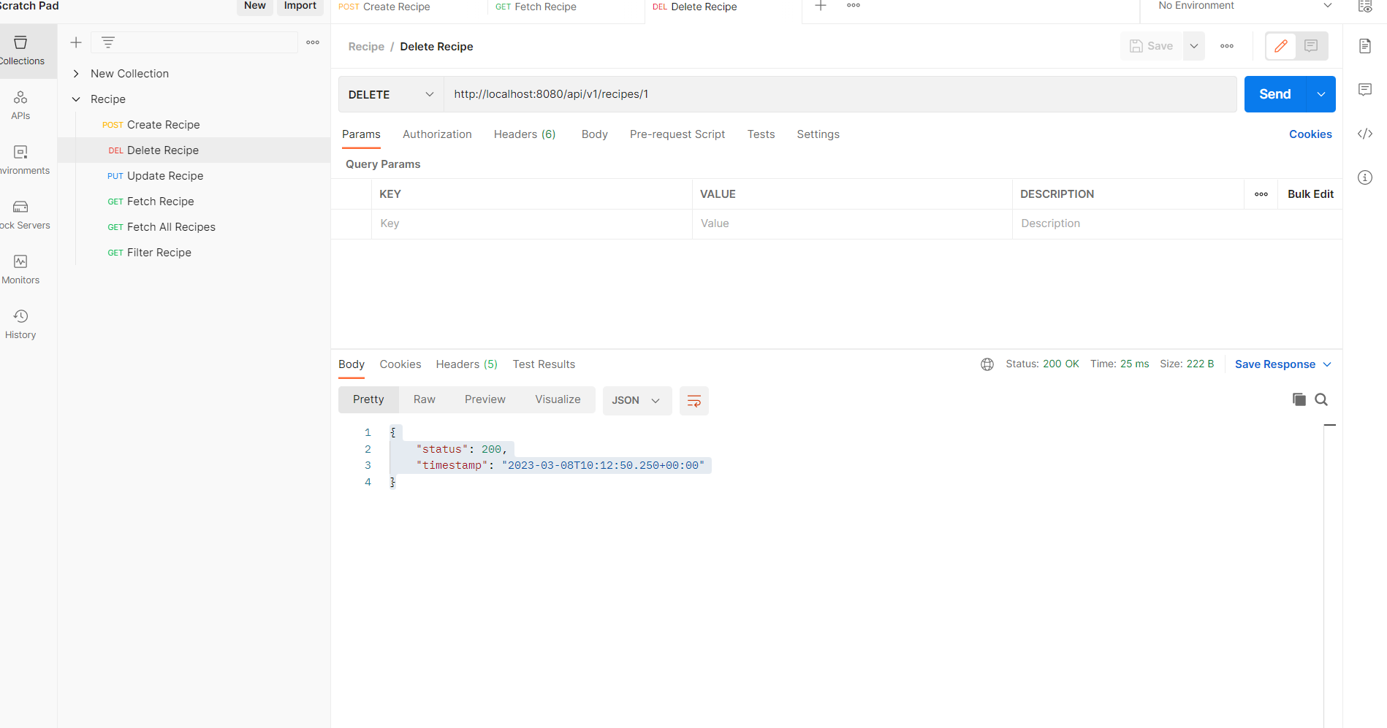

1. **Update Recipe by recipeId:**

Endpoint: [http://localhost:8080/api/v1/recipes/{recipeId}](http://localhost:8080/api/v1/recipes/%7brecipeId%7d)

Http Method: PUT

Request Body:

{

  "ingredients": [

     {

         "name":"Pepper 2"

     }

 ]

}

Response Body:

{

    "status": 200,

    "data": [

        {

            "name": "Chicken Biryani",

            "recipeId": 2,

            "dishType": "Non Veg",

            "instruction": "instruction",

            "ingredients": [

                {

                    "ingredientId": 2,

                    "name": "salt 2 spoons"

                },

                {

                    "ingredientId": 3,

                    "name": "Pepper 2"

                }

            ]

        }

    ],

    "timestamp": "2023-03-08T10:15:30.153+00:00"

}

Example:

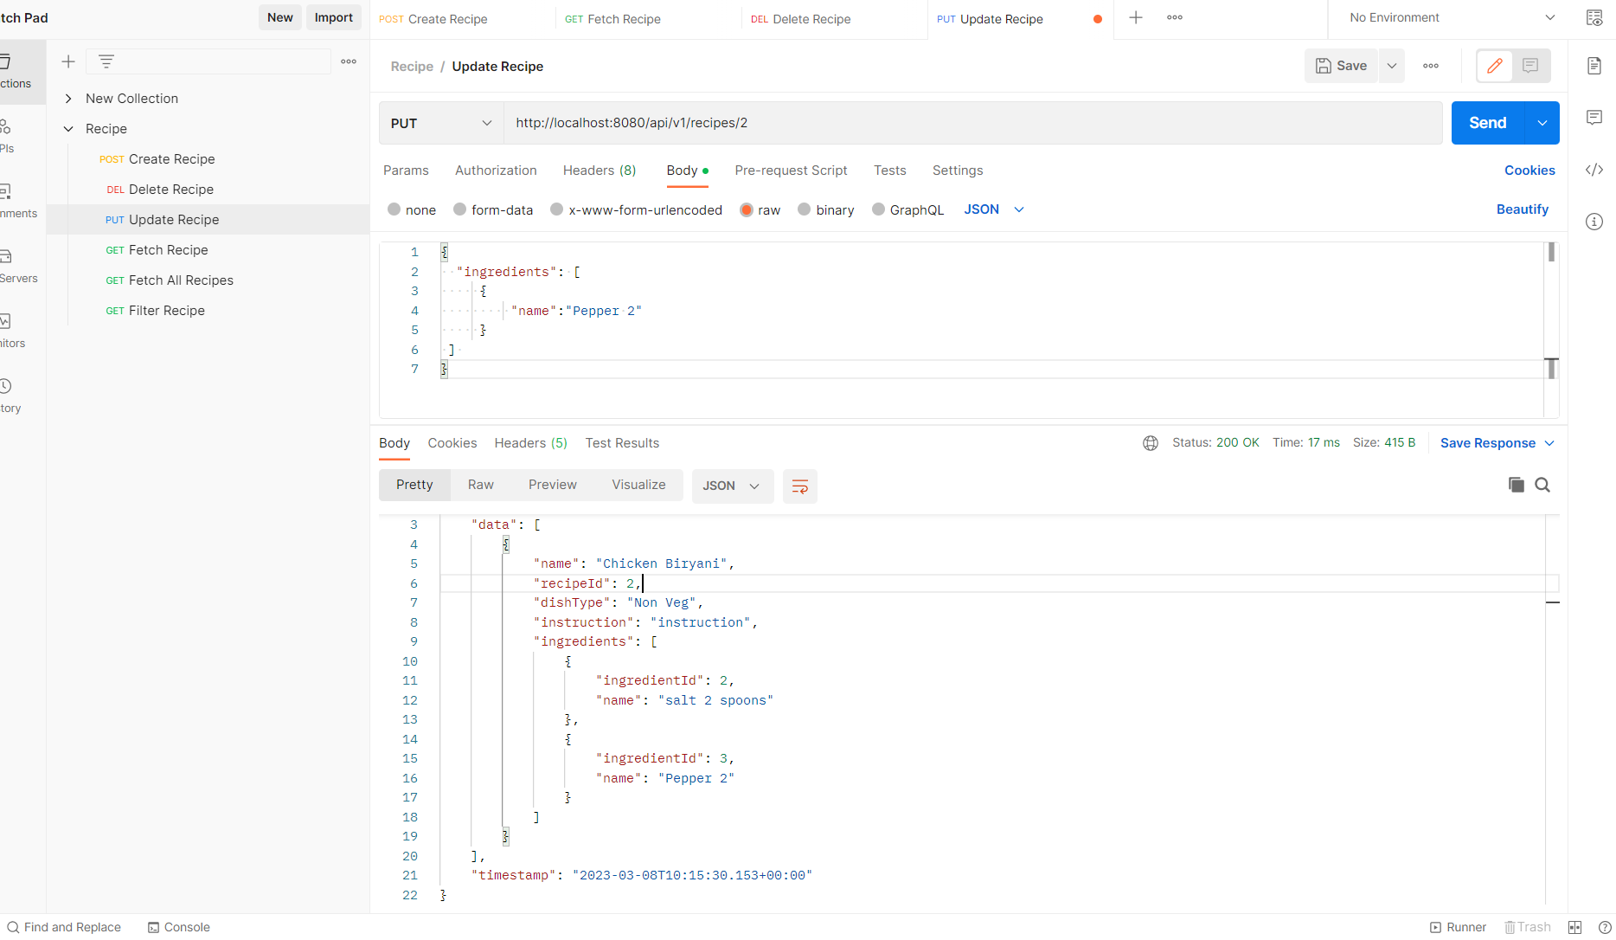

1. **Lookup Recipes:**

Endpoint : [http://localhost:8080/api/v1/recipes/search?&dishType={dishType}&serves={serves}&instruction={instruction}&includeIngredients={ing1,ing2,}&excludeIngredients={ing1,in2,}](http://localhost:8080/api/v1/recipes/search?&dishType=%7bdishType%7d&serves=%7bserves%7d&instruction=%7binstruction%7d&includeIngredients=%7bing1,ing2,%7d&excludeIngredients=%7bing1,in2,%7d)

Http Method: GET

Request Body: No

Response Body:

{

    "status": 200,

    "data": [

        {

            "name": "Chicken Biryani",

            "recipeId": 2,

            "dishType": "Non Veg",

            "instruction": "instruction",

            "ingredients": [

                {

                    "ingredientId": 2,

                    "name": "salt 2 spoons"

                },

                {

                    "ingredientId": 3,

                    "name": "Pepper 2"

                }

            ]

        }

    ],

    "timestamp": "2023-03-08T10:17:26.415+00:00"

}

Example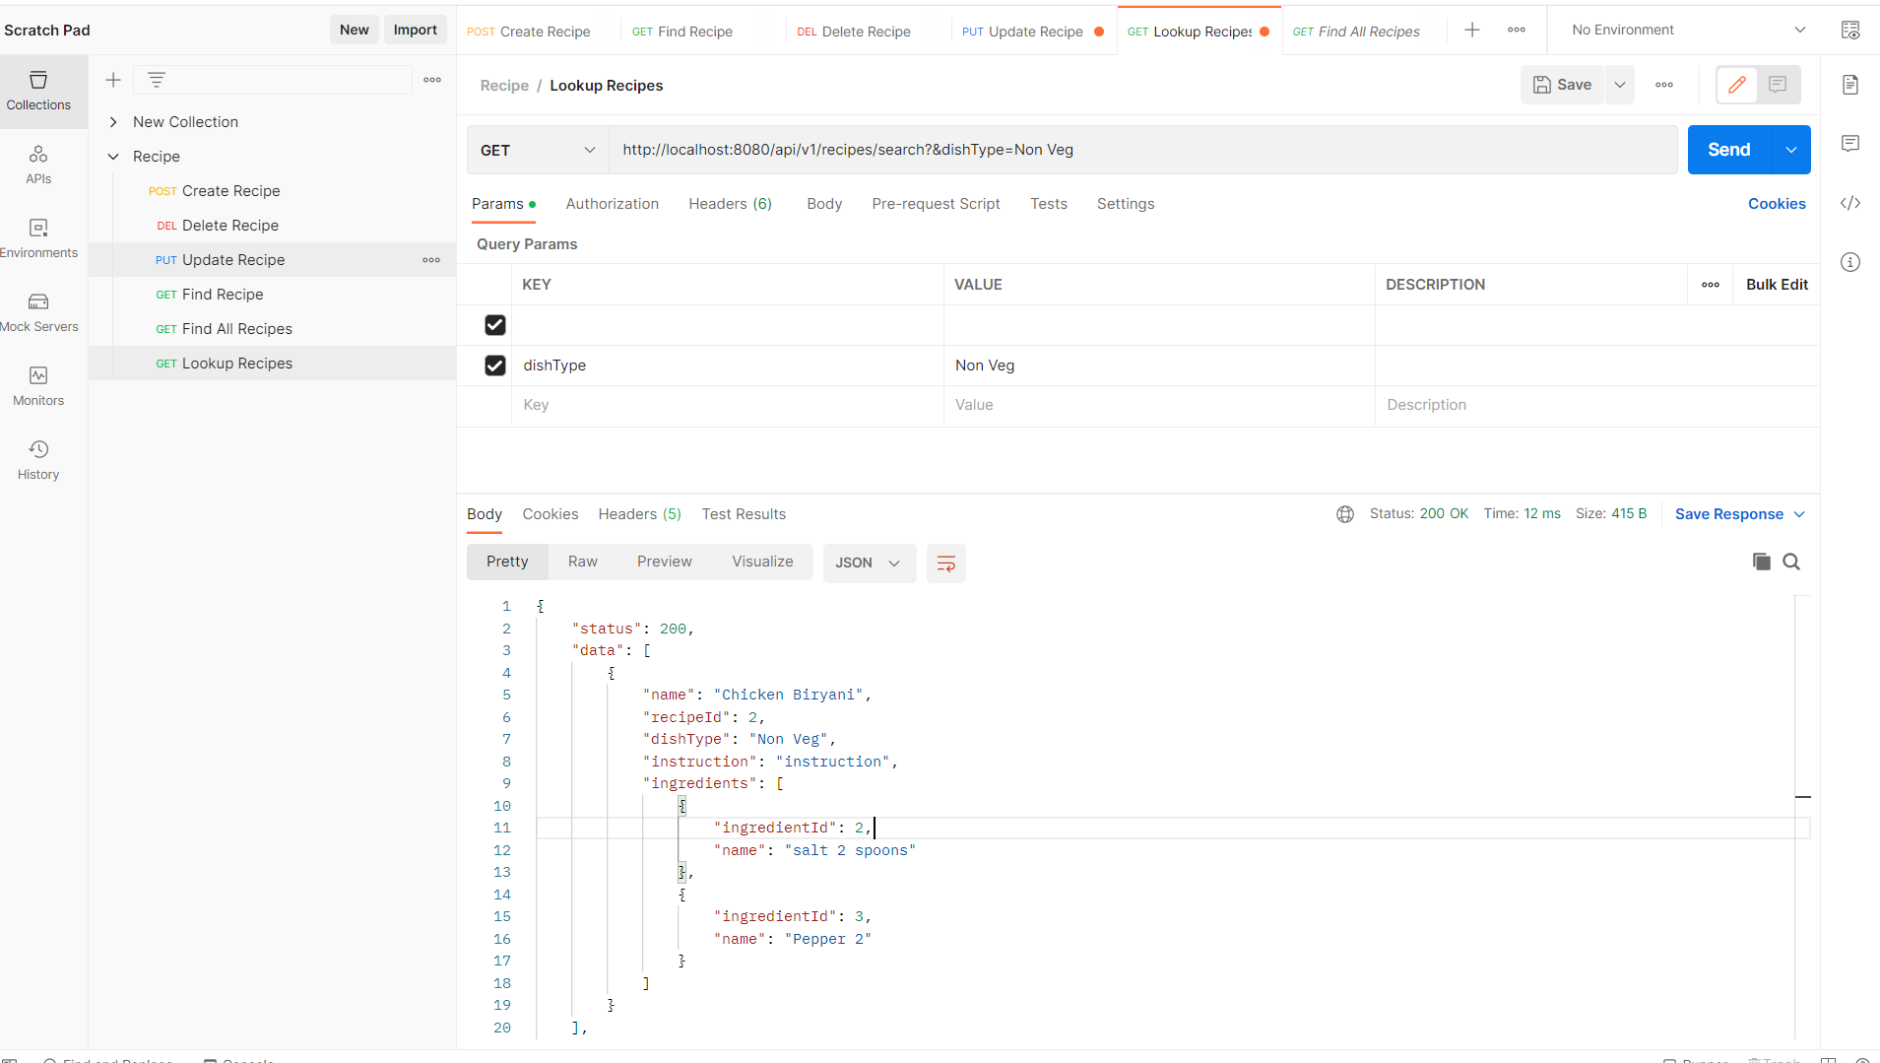

1. **Find All Recipes:**

Endpoint: <http://localhost:8080/api/v1/recipes>

Http Method: GET

Request Body: No

Response Body:

{

    "status": 200,

    "data": [

        {

            "name": "Chicken Biryani",

            "recipeId": 2,

            "dishType": "Non Veg",

            "instruction": "instruction",

            "ingredients": [

                {

                    "ingredientId": 2,

                    "name": "salt 2 spoons"

                },

                {

                    "ingredientId": 3,

                    "name": "Pepper 2"

                }

            ]

        }

    ],

    "timestamp": "2023-03-08T10:26:22.044+00:00"

}

Example:

